2026 INTERNSHIP REPORT

**Submitted to : Smart Internz ,Smart Bridge company Track : Data Analytics with Tableau**

**Project Title : Strategic Product Placement Analysis: Unveiling Sales Impact with Tableau Visualization**

**Submitted by:**

**Team ID :LTVIP2026TMIDS66456**

**Team Leader : Kesamsetti Lahari**

**Team member :Alla Swapna**

**Team member : Vanipenta Hemanth Reddy**

**Team member : Badugu Rajesh**

**From:Kallam Haranadha Reddy Institute Of Technology**

# INTRODUCTION

* 1. **Project Overview**

**Project Title:**

**Strategic Product Placement Analysis: Unveiling Sales Impact with Tableau Visualization**

**Project Summary:**

This project focuses on analyzing the effectiveness of strategic product placements within retail or e-commerce environments and visualizing their impact on sales using Tableau. By leveraging historical sales data and visual analytics, the project aims to uncover patterns, trends, and actionable insights that inform optimal product positioning strategies to maximize revenue.

### Objectives:

* + - Analyze sales performance based on different product placement strategies.
    - Identify high-performing placement zones (e.g., end-caps, eye-level shelves, homepages).
    - Create interactive Tableau dashboards to visualize placement vs. sales correlations.
    - Provide actionable recommendations for inventory and layout optimization.

### Scope:

**In-Scope:**

* + - Data cleaning and preparation of sales and product placement data.
    - Exploratory data analysis using Tableau.
    - Creation of dashboards illustrating sales trends, heatmaps, and product performance by location.
    - Insights and reporting for stakeholders on placement effectiveness.

### Out-of-Scope:

* + - Real-time placement optimization system development.
    - Hardware implementation for in-store product tracking.

### Timeline:

* + - **Week 1–2:** Data collection and preprocessing
    - **Week 3–4:** Exploratory data analysis and initial dashboard development
    - **Week 5:** Insights generation and final dashboard enhancements
    - **Week 6:** Report preparation and presentation

### Key Stakeholders:

* + - **Project Sponsor:** Smart Bridge Company
    - **Project Manager:** Indra Prakash sir

### Data Analyst / Visualization Developer:

* Team Leader : Pidatala Harshita
* Team member : Nallamothu Ayyappa Venkata Surya
* Team member : Muthireddy Narendra
* Team member : Nalla Hemanth Kumar

**End Users:** Marketing and Sales Teams, Inventory Managers

### Tools & Technologies:

* + - Tableau for data visualization
    - Excel/SQL/Python for data preprocessing (optional)
    - Retail sales and placement datasets

### Risks and Dependencies:

* + - **Risk:** Incomplete or inconsistent placement data
    - **Mitigation:** Work with stakeholders to define placement tags clearly
    - **Dependency:** Timely access to historical sales and product layout data
  1. **purpose:**

### The purpose of the "Strategic Product Placement Analysis: Unveiling Sales Impact with Tableau Visualization" project is to evaluate how product placement strategies influence sales performance and to present these insights through interactive Tableau dashboards.

By understanding the relationship between **where products are placed** (e.g., shelf level, store zone, website layout) and **how well they sell**, the project aims to:

* Help businesses **optimize product positioning** to increase visibility and drive higher sales.
* Provide **data-driven insights** that support strategic marketing, merchandising, and inventory decisions.
* Enable stakeholders to **interactively explore sales trends** and identify opportunities for improving product placement effectiveness.

In essence, the project bridges the gap between **visual analytics** and **retail strategy**, empowering decision-makers with clear, actionable data to enhance product performance through smarter placement.

# IDEATION PHASE:

* 1. **Problem Statement:**

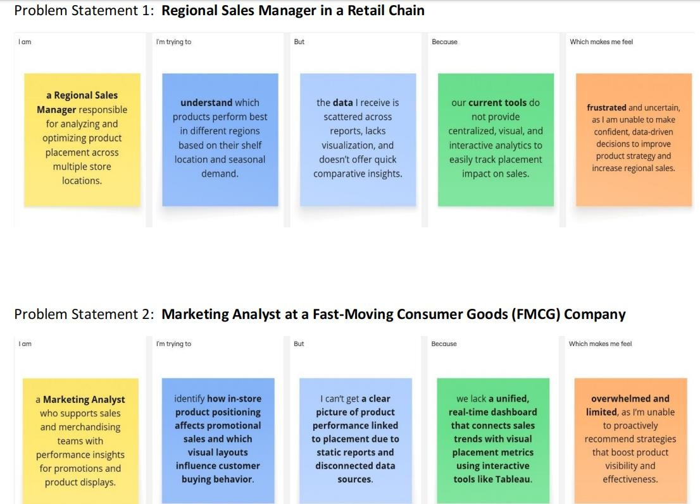

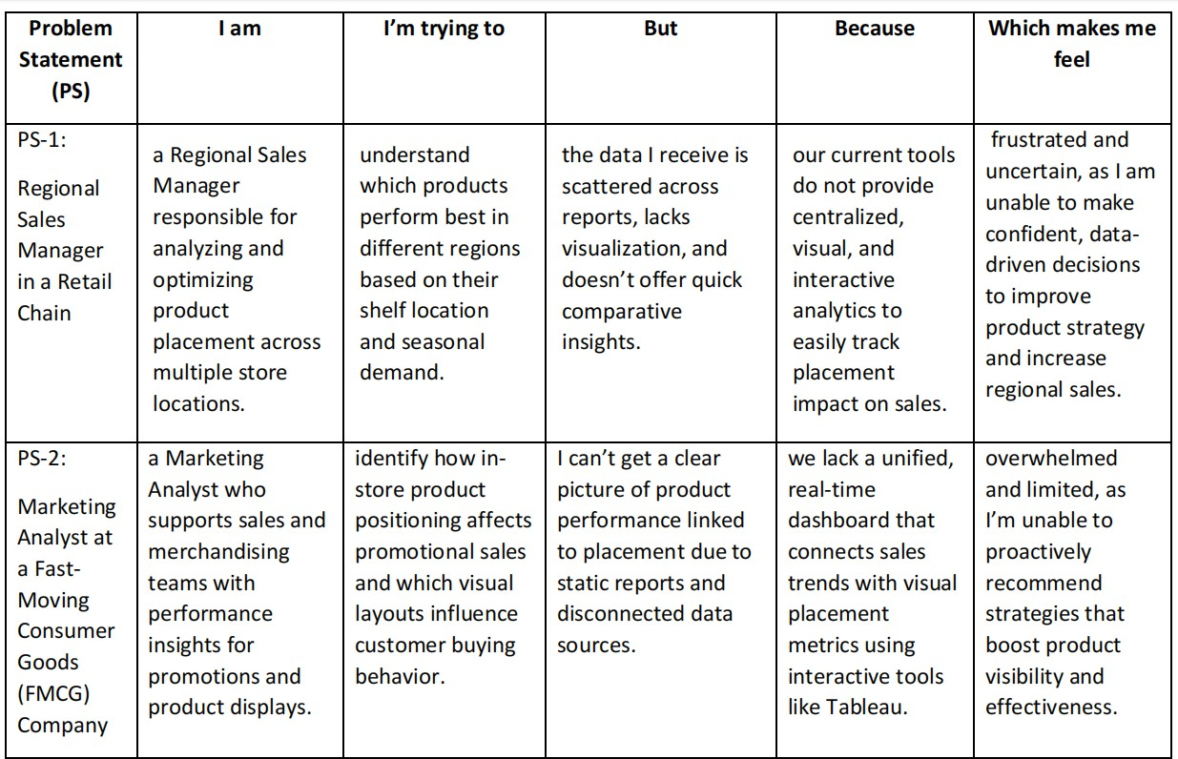

* 1. **Empathy Map Canvas:**

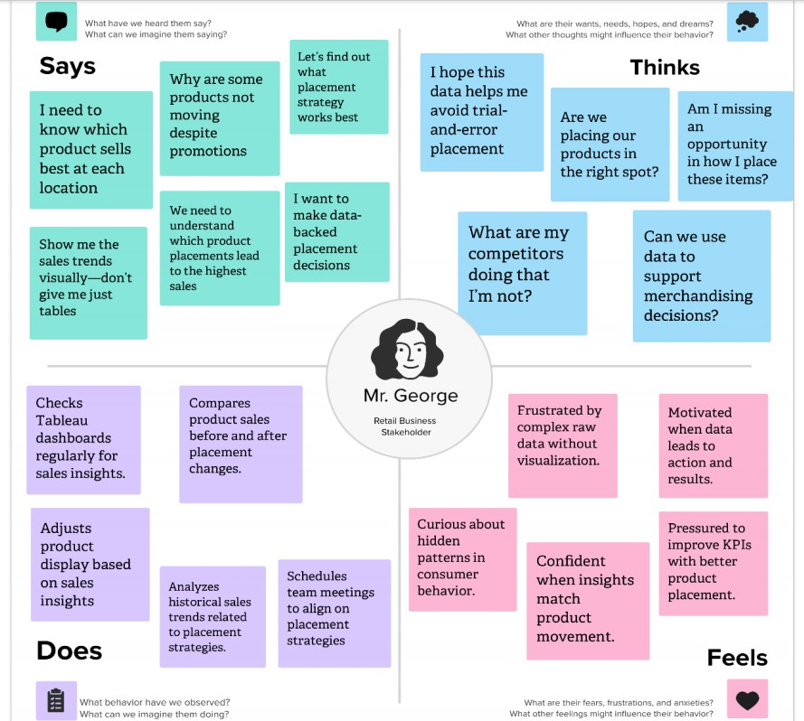

* 1. **Brainstorming:**

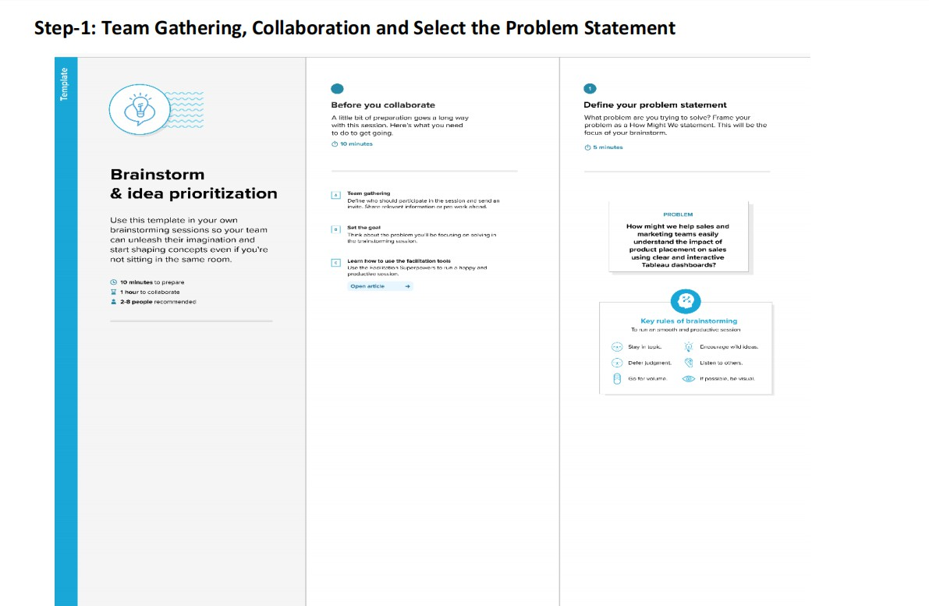



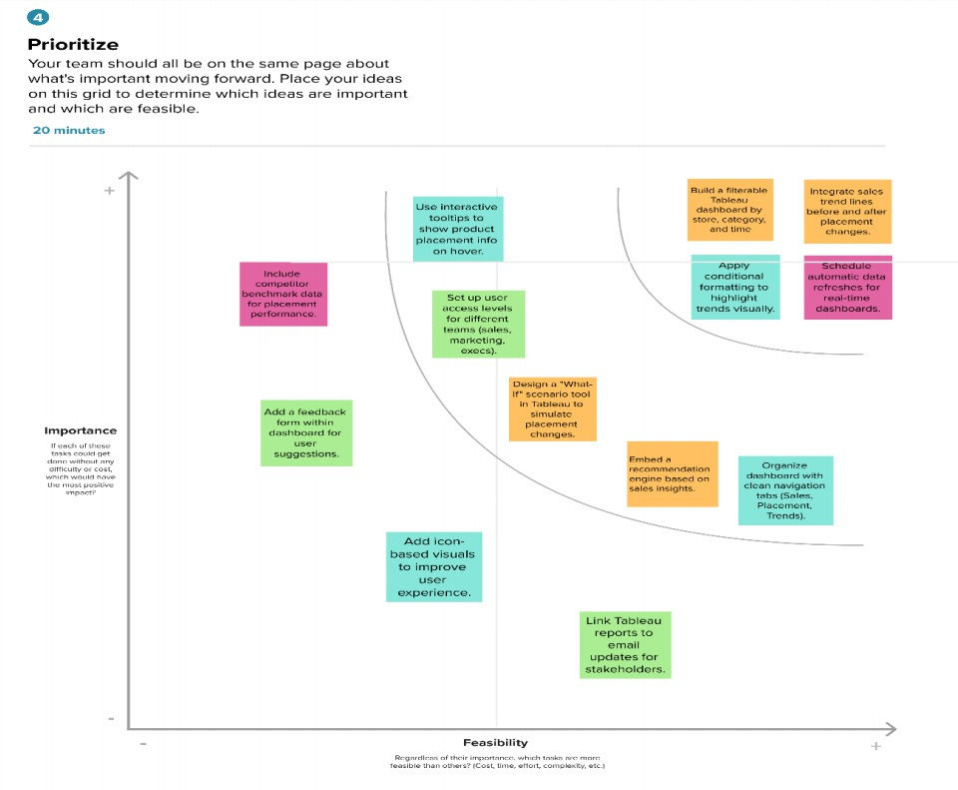

# REQUIREMENT ANALYSIS :

* 1. **Customer Journey Map :**

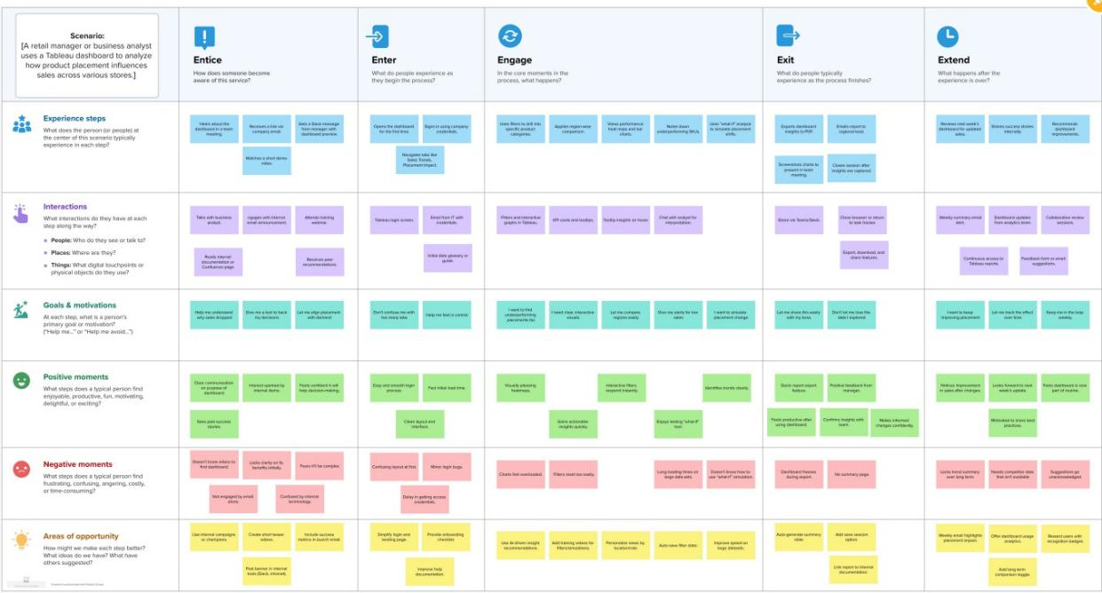

* 1. **Solution Requirement:**

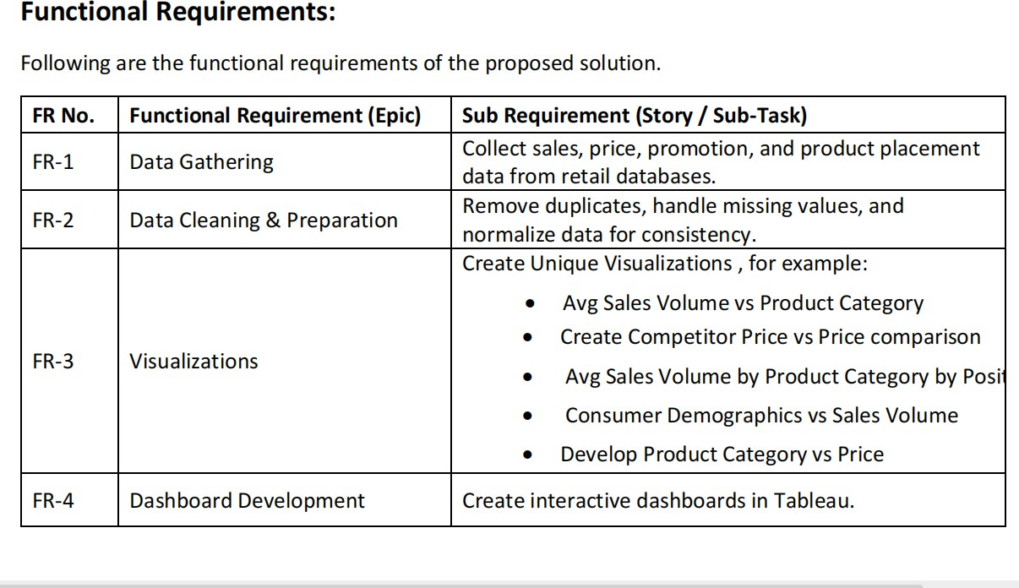

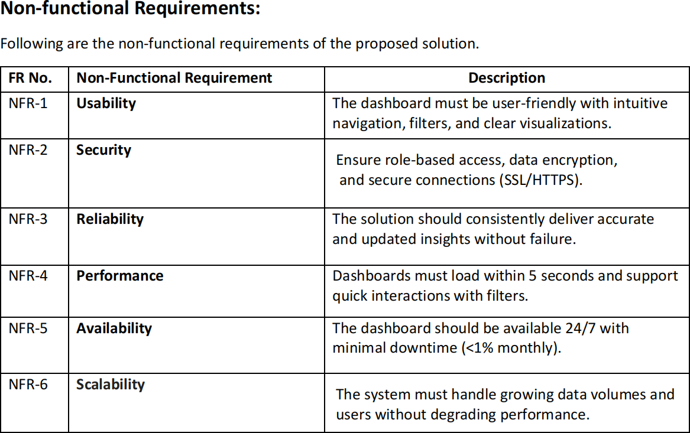

* 1. **Data Flow Diagram:**

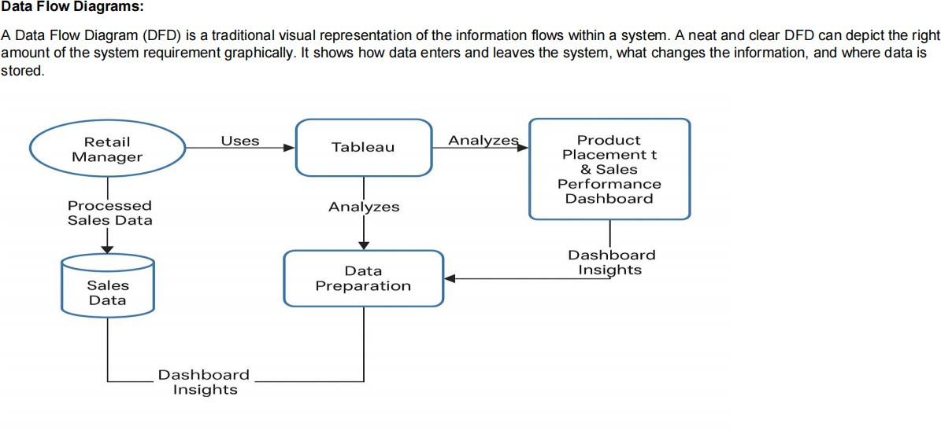

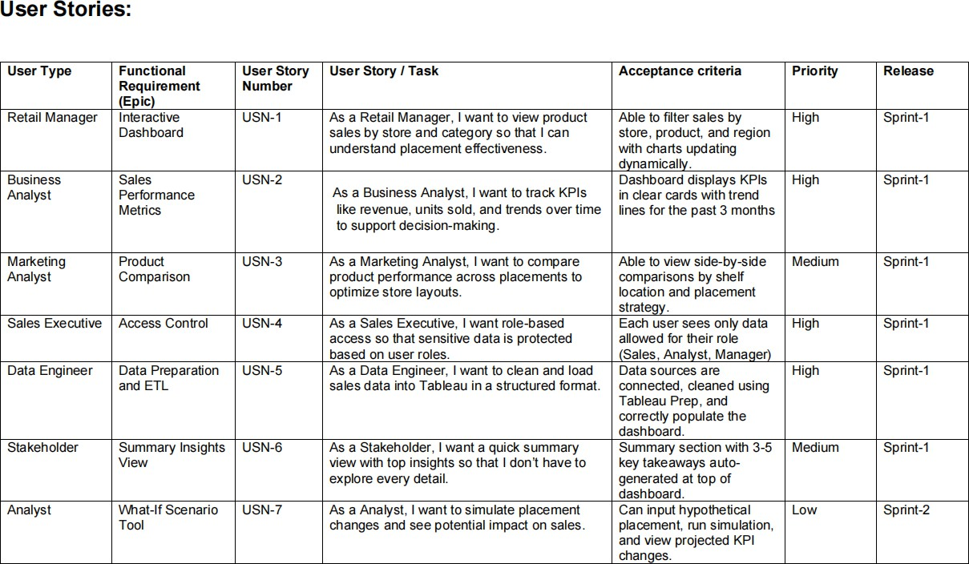

* 1. **Technology Stack:**

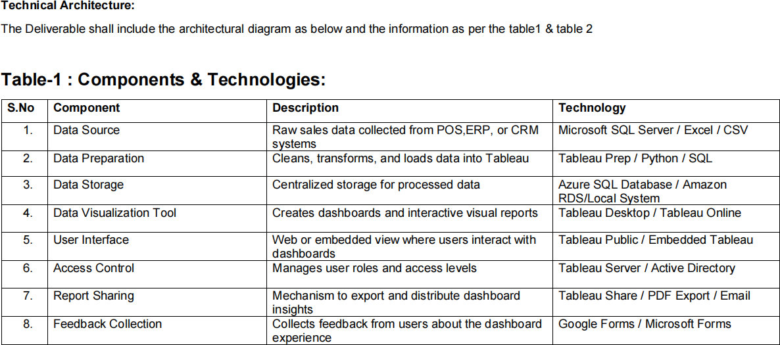

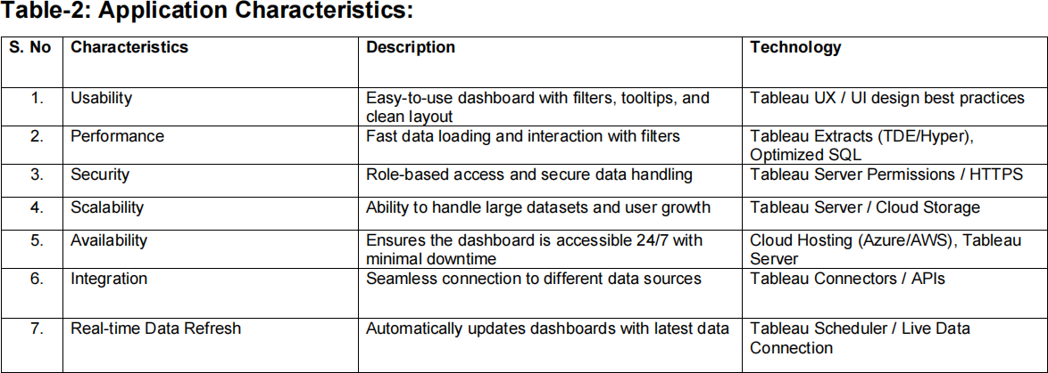

# PROJECT DESIGN:

* 1. **Problem solution Fit:**

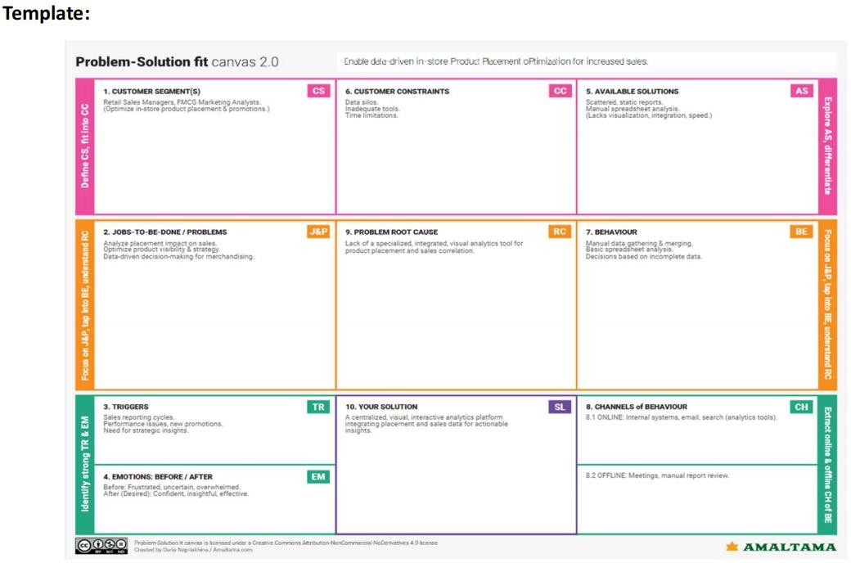

* 1. **Proposed Solution:**

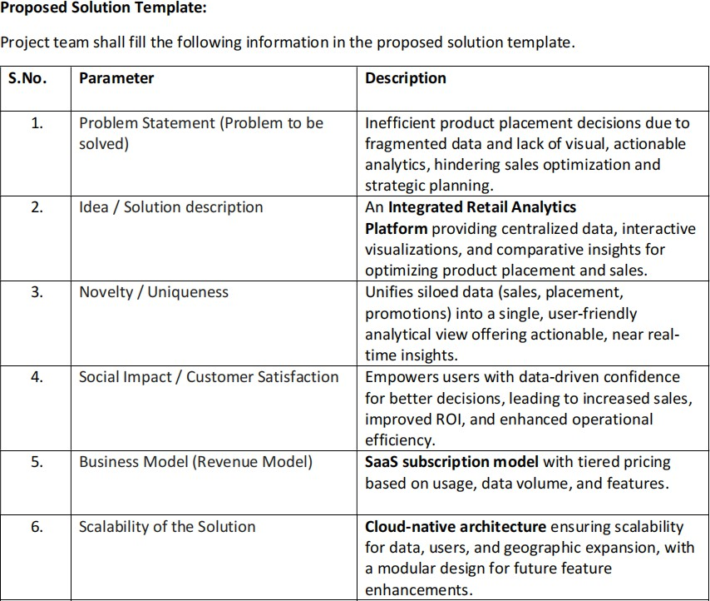

* 1. **Solution Architecture:**

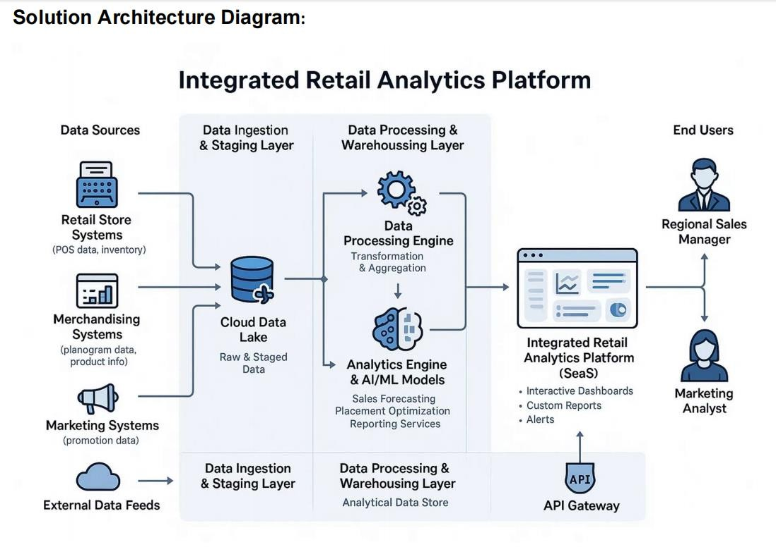

# PROJECT PLANNING & SCHEDULING:

* 1. **Project planning:**

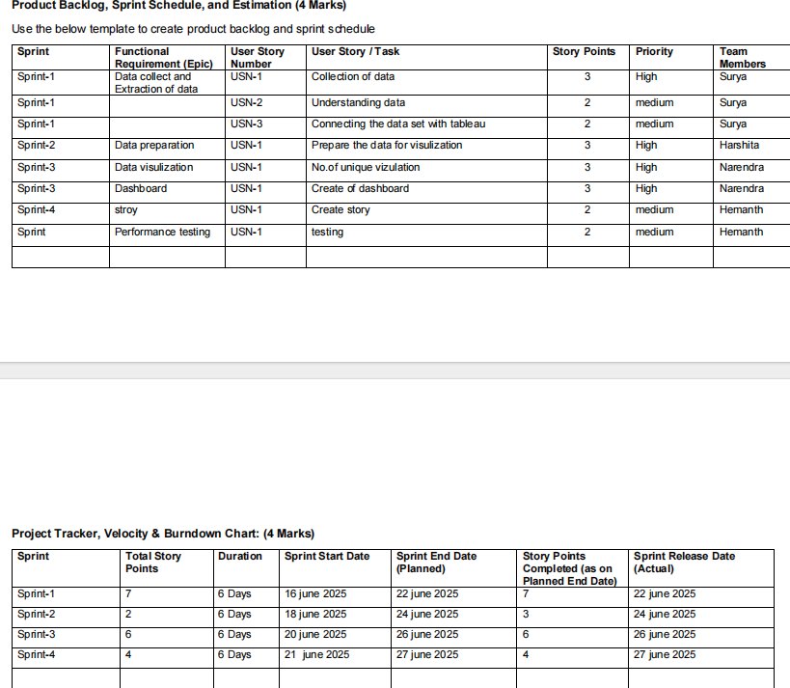

# FUNCTIONAL AND PERFORMANCE TESTING:

* 1. **Performance Testing:**

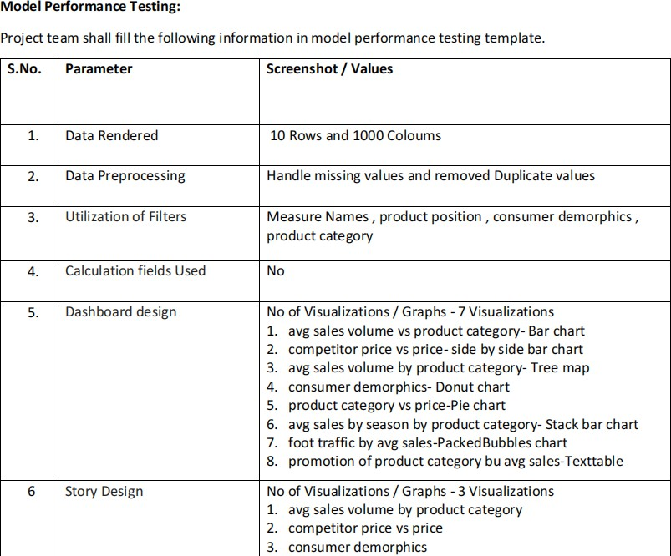

# RESULTS:

* 1. **Output Screenshot:**

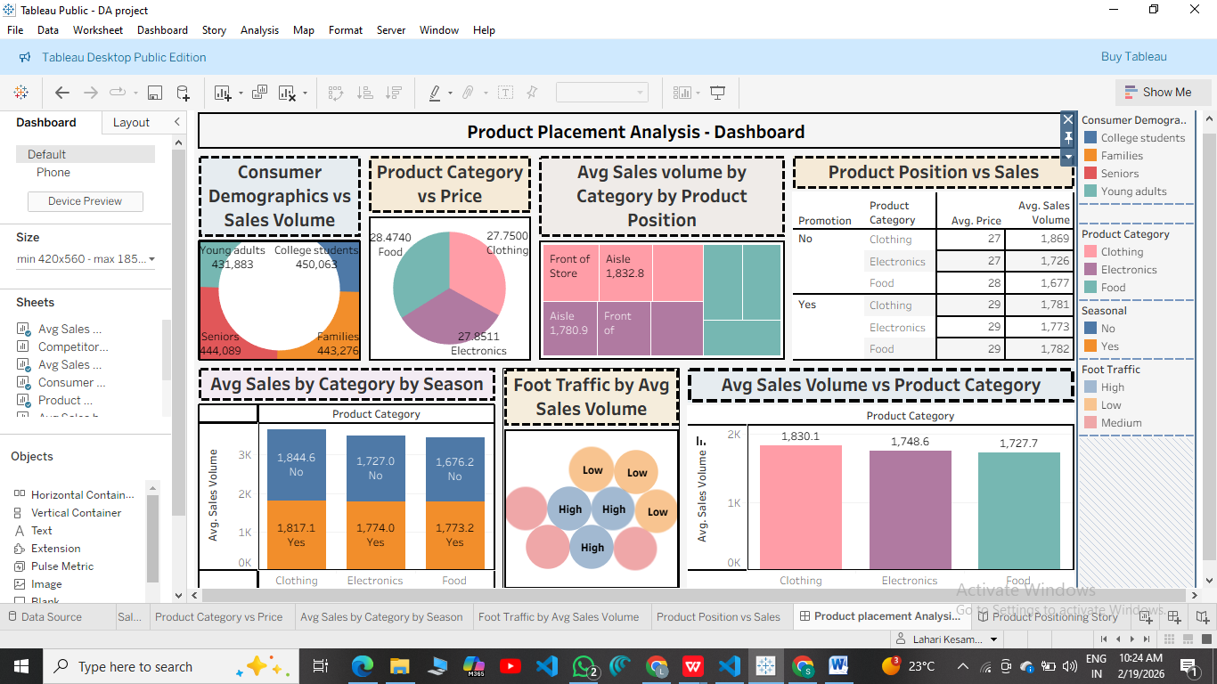

**Story:**

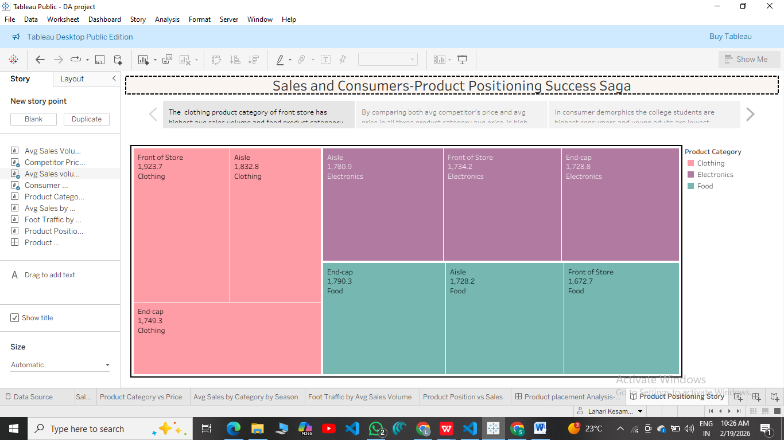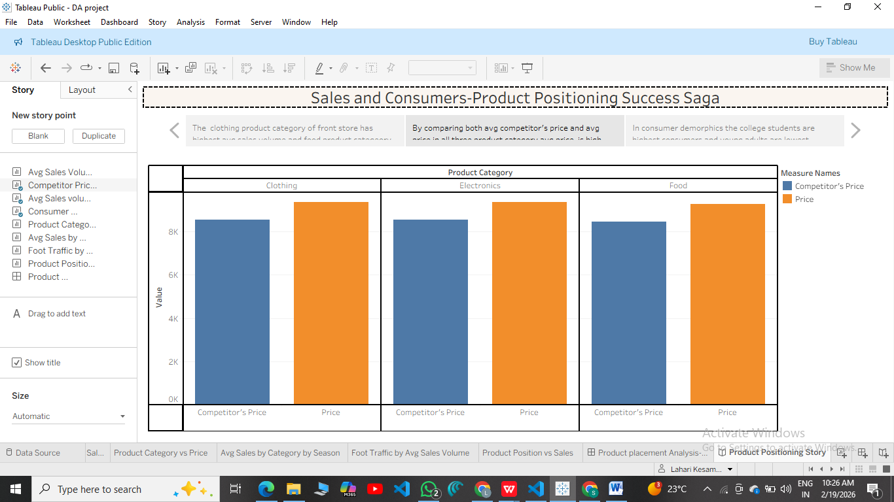

1. **ADVANTAGES & DISADVANTAGES :**

**Advantages:**

**Data-Driven Decision Making:**

**Helps retailers and marketers make informed decisions about where to place products to maximize sales.**

**Improved Sales Performance:**

* Identifies optimal product placement strategies, leading to increased product visibility and potentially higher revenue.

## Customer Behavior Insights:

* Reveals buying patterns and foot traffic trends, improving understanding of customer preferences.

## Effective Use of Tableau:

* Provides interactive, visual insights that are easy for stakeholders to interpret, even without technical backgrounds.

## Cost Optimization:

* Helps reduce wasted shelf space and inefficient layouts by showing which placements yield poor returns.

## Competitive Advantage:

* Businesses using advanced analytics gain an edge over competitors relying on intuition alone.

**Disadvantages:**

## Data Dependency:

* Requires large volumes of accurate and up-to-date sales and placement data; poor data quality can mislead conclusions.

## Complexity in Setup:

* Initial setup for data collection, integration, and visualization in Tableau can be time-consuming and require technical expertise.

### Dynamic Market Conditions:

* Consumer preferences and market trends change frequently, making it hard to maintain consistently optimal placements.

### Tool Limitations:

* Tableau is a powerful tool, but it may have limitations in advanced predictive modeling or real-time analytics compared to specialized tools.

### Cost of Implementation:

* Investment in tools, training, and data infrastructure may be significant for small businesses.

### Over-reliance on Visualization:

* Users might focus more on visuals than on underlying business logic, possibly ignoring key qualitative insights.

# CONCLUSION:

The **"Strategic Product Placement Analysis"** project, enhanced with **Tableau visualization**, serves as a powerful approach for businesses aiming to optimize product positioning and drive sales growth. By leveraging data analytics, companies can gain actionable insights into customer behavior, shelf performance, and layout efficiency. While there are challenges such as data requirements and implementation complexity, the benefits—like improved sales, informed decision-making, and competitive advantage—far outweigh the drawbacks when executed properly. Overall, this project empowers businesses to make smarter merchandising decisions and adapt quickly in a competitive retail environment.

This analysis proves that intuitive product placement alone is no longer sufficient in today's data-centric retail world. Incorporating visual analytics provides a scalable and repeatable method to evaluate and refine placement strategies across different store formats and product categories.

While the project presents strong advantages, it also highlights the importance of maintaining high-quality data and regularly updating insights to keep up with changing consumer trends. Strategic product placement should be seen as an ongoing, dynamic process rather than a one-time task.

# FUTURE SCOPE :

### Integration with Real-Time Data:

* Incorporate real-time sales and inventory data to enable dynamic product placement adjustments based on current trends and demand.

### AI & Machine Learning Enhancements:

* Use predictive analytics and machine learning models to forecast sales performance based on proposed placements and customer behavior patterns.

### Customer Heatmap & Footfall Analysis:

* Integrate in-store sensor data or camera-based heatmaps to track customer movement and identify high-traffic zones for optimal product placement.

### Cross-Channel Analysis:

* Extend the analysis to include online sales and digital shelf performance, providing a unified view across physical and digital storefronts.

### Personalized In-Store Experiences:

* Combine placement data with customer profiles and loyalty data to tailor shelf arrangements and promotions for targeted customer segments.

### Automation of Reporting:

* Set up automated dashboards in Tableau that update periodically, reducing manual effort and improving decision-making speed.

### Scalability to Multiple Locations:

* Apply the framework across multiple stores or regions to compare and optimize placement strategies in different demographics and layouts.

### Integration with Augmented Reality (AR):

* Use AR to visualize proposed placement changes before implementing them in physical spaces, aiding in layout planning and testing.

### Sustainability and Waste Reduction:

* Use insights to minimize overstocking and underperforming placements, contributing to more sustainable inventory practices.

### Collaboration with Marketing Campaigns:

* Link product placement strategies with promotional campaigns to evaluate their combined impact on sales and customer engagement.

1. **Acknowledgement / Thank You Note:**

I would like to express my heartfelt gratitude to **Indraprakash Sir**, my internship mentor, for his continuous guidance, support, and encouragement throughout this project. His expertise and insights have been invaluable in shaping my understanding of data analytics and visualization.

I also extend my sincere thanks to **SmartInternz** for providing this valuable opportunity to work on a real-world project and gain practical experience in tools like Tableau. This internship has been an enriching and rewarding learning journey.

Thank you once again for your constant support and mentorship.

11. **APPENDIX:**

**Tools & Technologies Used**

**Tableau Public / Desktop** – For data visualization and dashboard creation **Microsoft Excel** – For data cleaning, preparation, and preprocessing **Google Sheets** – For online collaboration and dataset sharing **SmartInternz Platform** – For internship guidance and submissions

## Data set link:

[https://docs.google.com/spreadsheets/d/1rdNSpWYKrZdNANNhTkIV1il](https://docs.google.com/spreadsheets/d/1rdNSpWYKrZdNANNhTkIV1ilQprXuy3OF/edit?usp=drivesdk&ouid=111671031581478693801&rtpof=true&sd=true) [QprXuy3OF/edit?usp=drivesdk&ouid=111671031581478693801&rtpof=](https://docs.google.com/spreadsheets/d/1rdNSpWYKrZdNANNhTkIV1ilQprXuy3OF/edit?usp=drivesdk&ouid=111671031581478693801&rtpof=true&sd=true) [true&sd=true](https://docs.google.com/spreadsheets/d/1rdNSpWYKrZdNANNhTkIV1ilQprXuy3OF/edit?usp=drivesdk&ouid=111671031581478693801&rtpof=true&sd=true)

## Tableau Public Link:

## [https://www.google.com/search?q=tableau+public&oq=table&gs_lcrp=EgZjaHJvbWUqBggBEEUYOzIGCAAQRRg8MgYIARBFGDsyBggCEEUYOTIGCAMQRRg7MgYIBBBFGDwyBggFEEUYPDIGCAYQRRg8MgYIBxBFGD3SAQg0MzI5ajBqN6gCCLACAQ&sourceid=chrome&ie=UTF-8](TableauPublicDesktop-64bit-2025-3-1.exe)

## Tableau public Dashboard and story links :

**Dashboard link :**

[https://public.tableau.com/views/DAproject_17706143617260/ProductplacementAnalysis-Dashboard?:language=en-US&publish=yes&:sid=&:redirect=auth&:display_count=n&:origin=viz_share_link](DA project)

## Story link:

[https://public.tableau.com/shared/ZFF5K5GCB?:display_count=n&:origin=viz_share_link](DAproject story)

## Web Integration link :

<https://smartbridge-nu.vercel.app/>

## Github link:

<https://github.com/>

## Video Demo link:

[https://drive.google.com/file/d/1k1GxElt0cbLyTackaevJFXz4vi1UgwTB/](https://drive.google.com/file/d/1k1GxElt0cbLyTackaevJFXz4vi1UgwTB/view?usp=drivesdk) [view?usp=drivesdk](https://drive.google.com/file/d/1k1GxElt0cbLyTackaevJFXz4vi1UgwTB/view?usp=drivesdk)